Below figure shows eq of line as:

**Y = mx + c**

c -> intercept on y.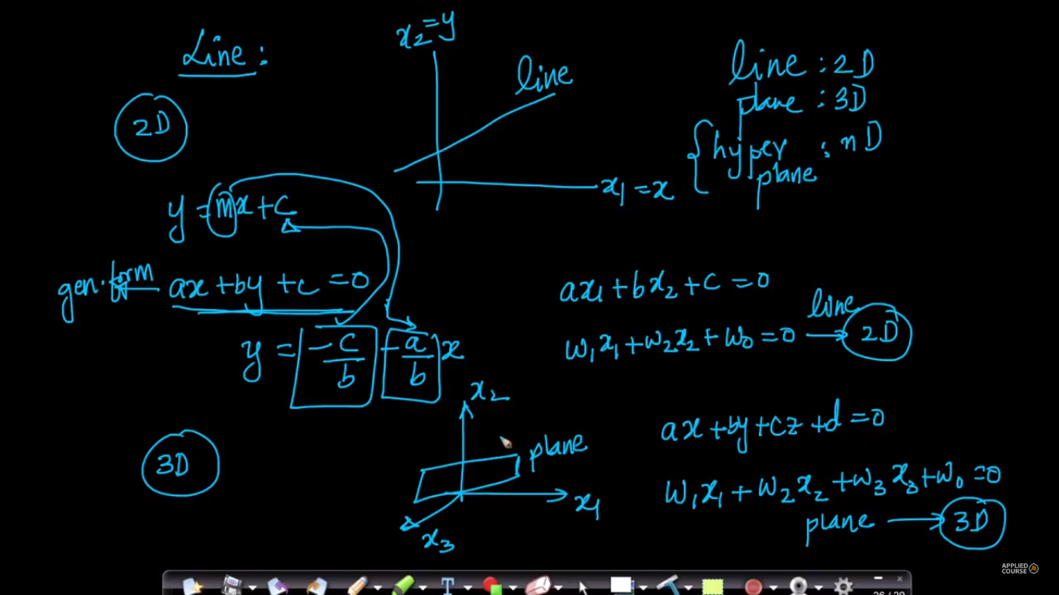

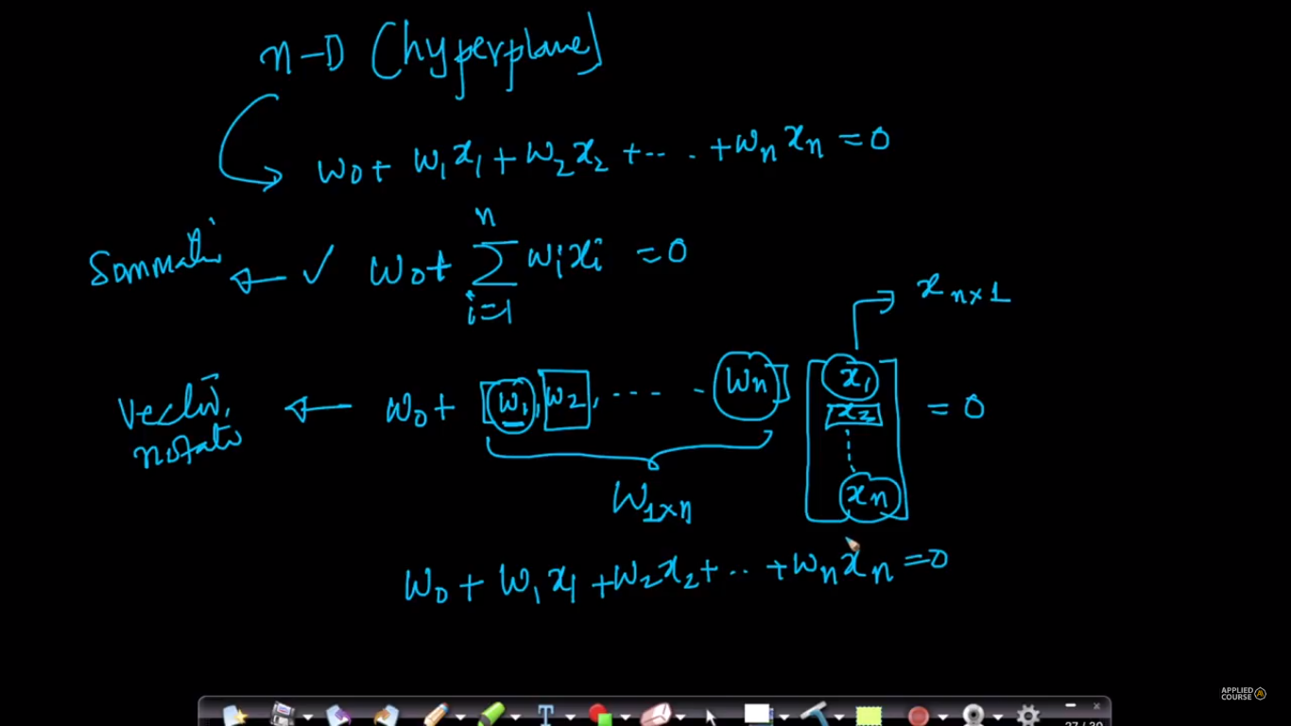

Plane is also written as 

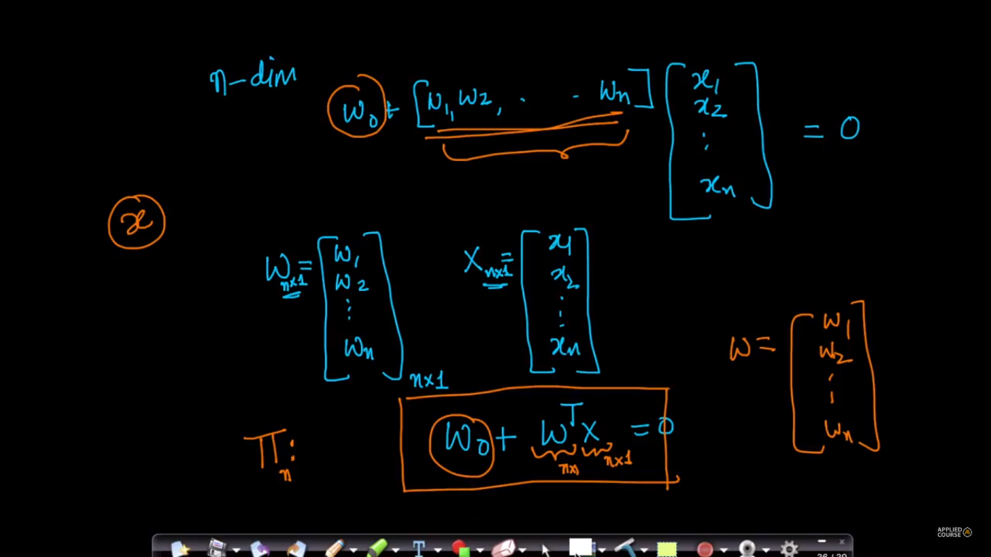

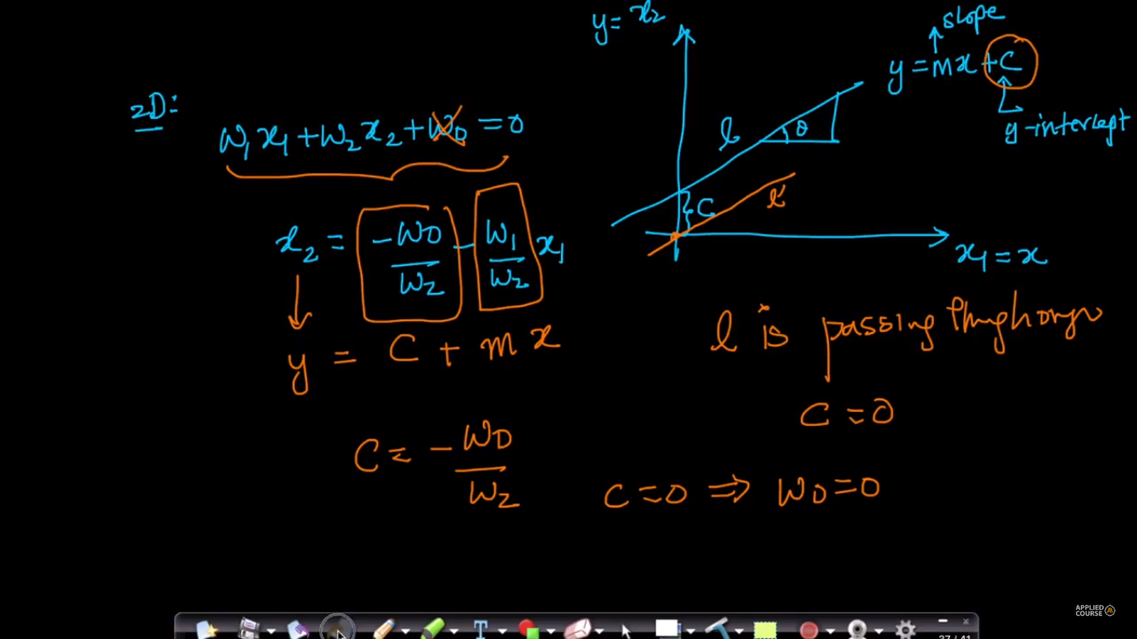

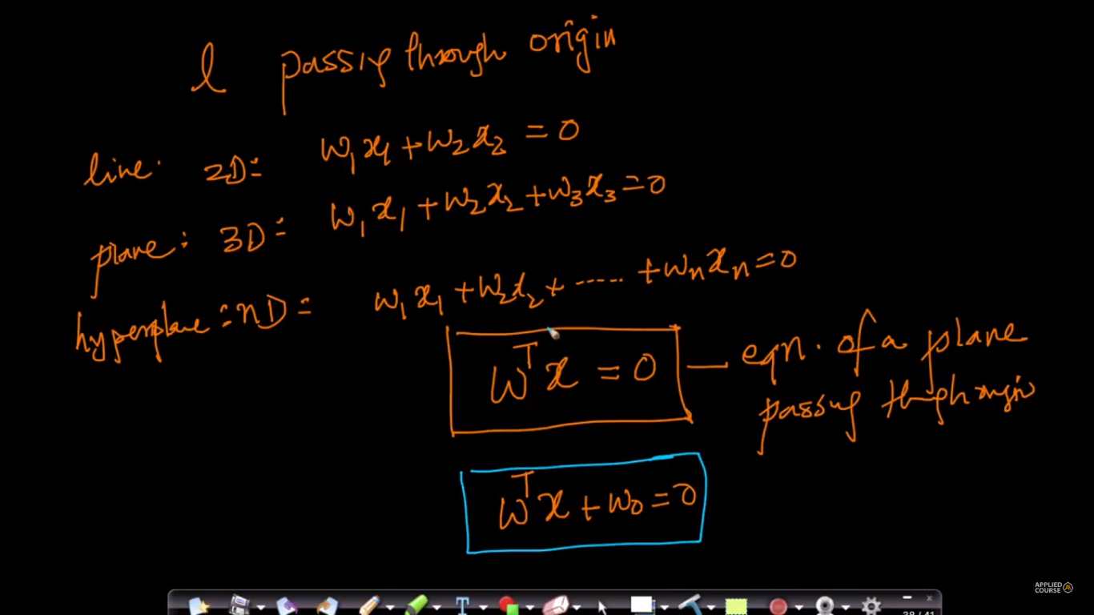

For any dimensional plane if w0 is 0, the vector w is perpendicular to vector x because, by generalized eq of plane wT x = 0, and product of two vector is ||w|| ||x|| cosθ = 0, that means θ is 90,

Therefore for any plane passing through origin the **w** vector is perpendicular to all value of **x**

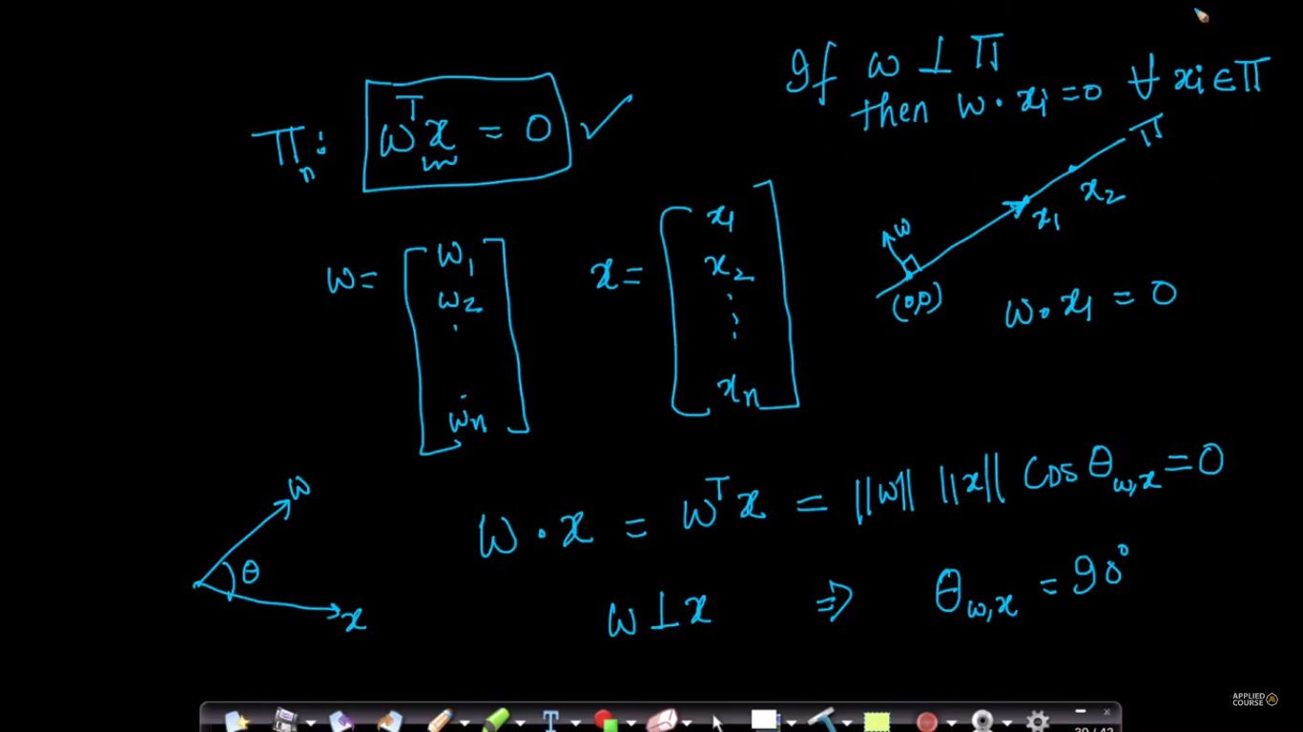

Below fig says that we always consider that plane passes through origin untill stated explicitly.

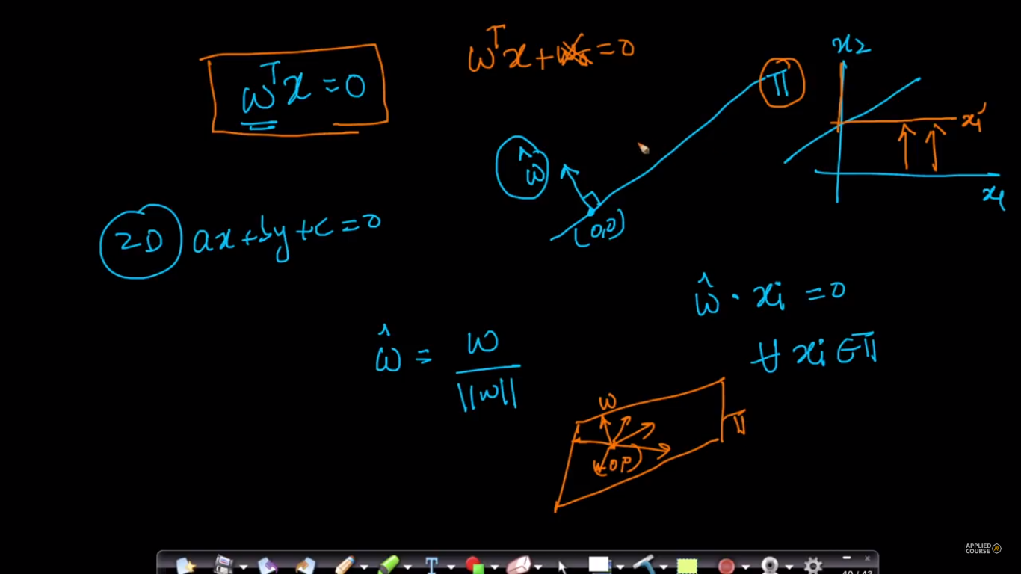

PTO

**How to find intercept of a plane on any axis in n-dimensions:**

Below figure show the intercept form of eq of a plane, given if intercept on x, y and z axis are a, b and c respectively.

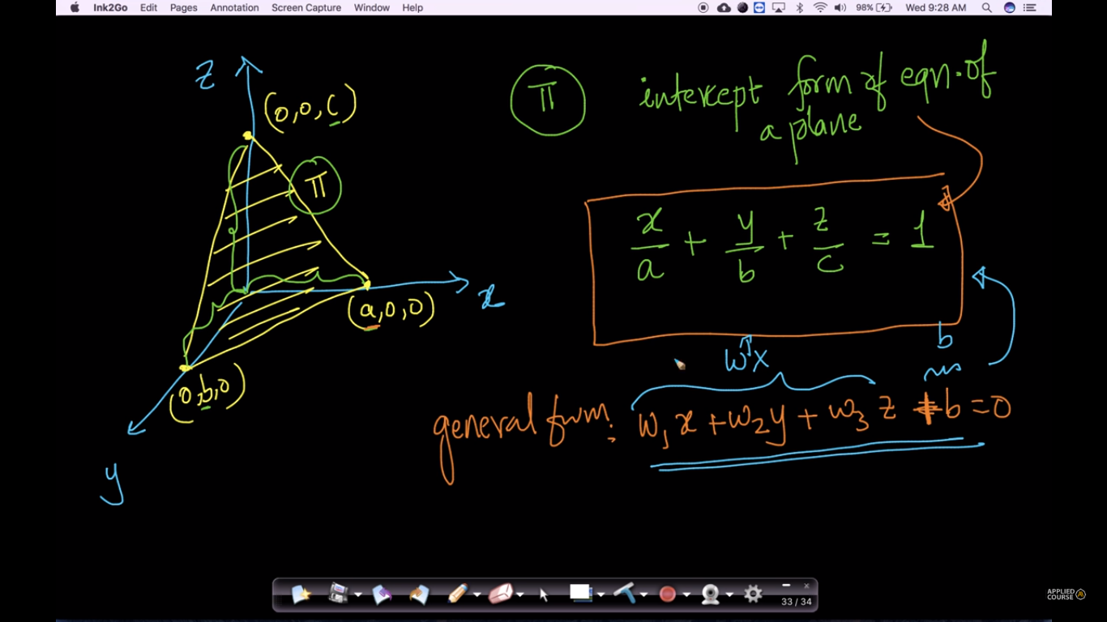

Below figure shows how to convert generalized equation of a plane into intercept form of plane equation to find intercept on each any axis, so on basis of below we can say that intercept on any axis(i) will **–b/wi**

